Dear Colleague,

One of my priorities as CEO of Imagine! is to create and preserve an environment where you enjoy your job, feel safe and work in a secure and ethical workplace. To aid in this endeavor, Imagine! has secured a hotline/helpline firm, EthicsPoint, to provide staff and other stakeholders additional methods to raise concerns about possible unethical or inappropriate behavior within our community. Issues or concerns may be filed by phone, through the Imagine! or EthicsPoint website, and, if preferred, may be made anonymously.

To access the EthicsPoint Reporting System from the Imagine! website, just go to the “Employee Center” tab on the navigation bar, and then choose “Employee Resources”. Then, click on “Ethics Reporting Hotline/Helpline” under
“Miscellaneous.” You can also go to www.ethicspoint.com and click on “Make a Report” or simply call the EthicsPoint toll-free hotline at 1-888-258-0151.

As we move forward, your input both through the EthicsPoint system and our traditional channels will be essential in ensuring that we maintain a positive and productive workplace. You have my promise that all reports will be reviewed and responded to in accordance with current policies and procedures.

Every person, regardless of position, shares in the responsibility for promoting a positive environment, and we can all work together on this.

Thank you for all you do to help make Imagine! such a great organization.

Sincerely,
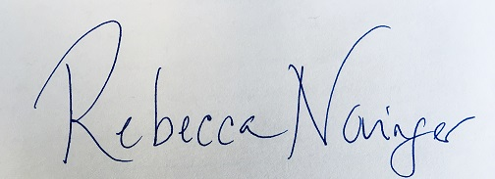
Rebecca Novinger
Chief Executive Officer

